Eduphoria – Forethought Lesson Planner

Logging On
To logon to forethought, from school, double click on the Eduphoria Icon on the staff page of the PISD website. https://plainview.schoolobjects.com/eduphoria_webcontrols/Login.aspx?ReturnUrl=%2feduphoria_webcontrols%2fApplications.aspx

At the login screen your username and login are the same as your Novell login.

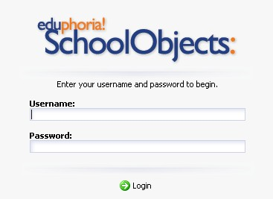Use the same login you use when you turn your computer on.

Setting Up Your Planner
The first time you log in, the Setup My Planner wizard will appear and guide you through:
- Setting up your schedule of courses
- Designing your default lesson template

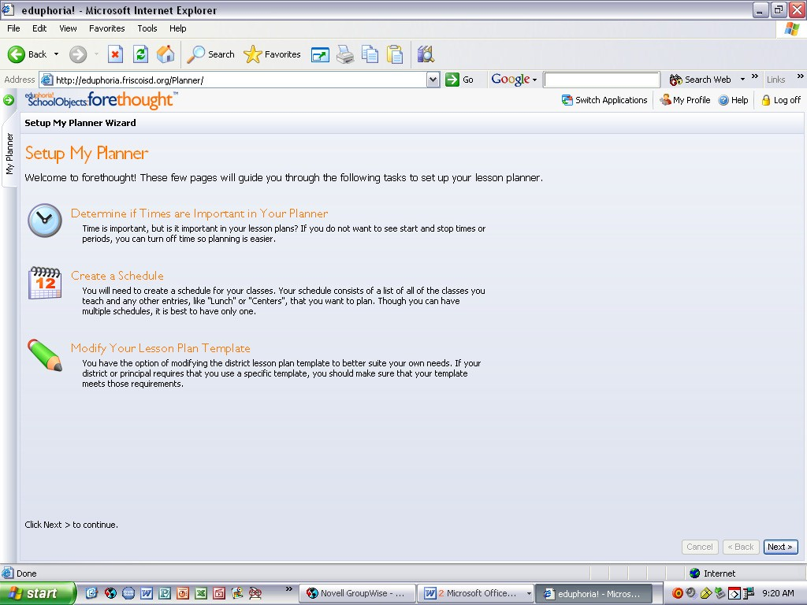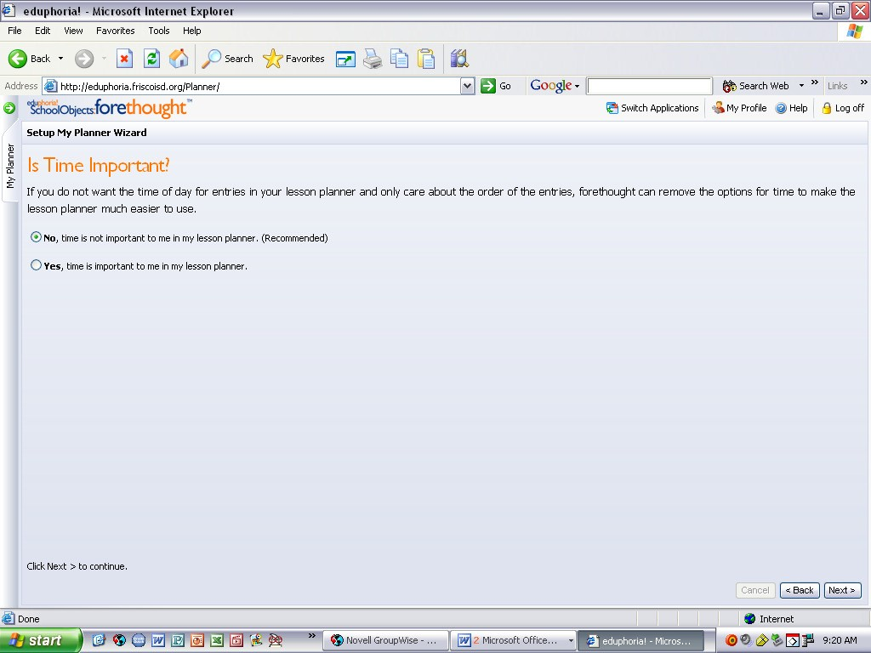Select No, time is
Click
NEX
T not important to me.
(We can add times at a later point if you need to.)
Click NEXT

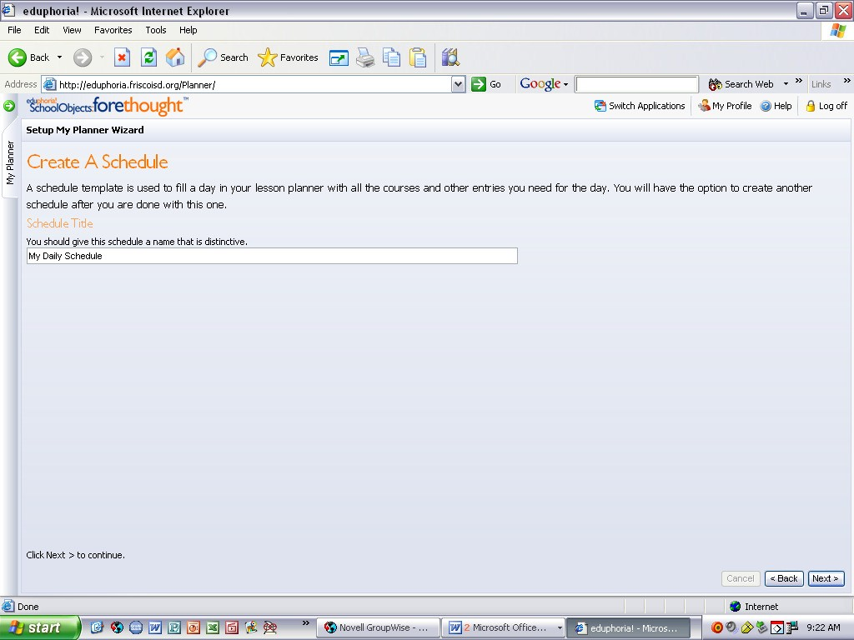Give your schedule a name. This will probably be the only schedule you will need, so a general name would be appropriate.
Something like My Daily Schedule will work.

Click NEXT

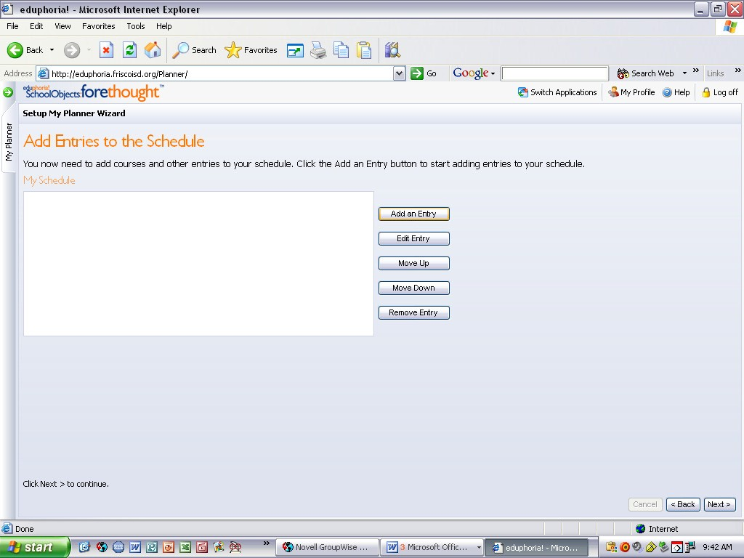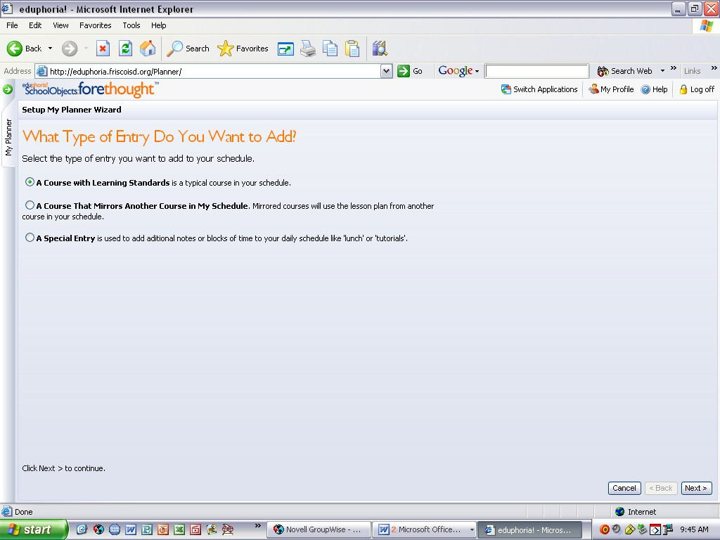
This screen allows you to add, edit, and
organize the entries in your schedule.

First select Add an Entry.
What Type of Entry Do You Want To Add?

- A Course with learning standards – will be a class/section that has TEKS (i.e. Math, Language Arts, Science, etc.).
- A course that mirrors another course in my schedule – This will be for 4th & 5th Grade at this time.
- A Special Entry – will be a general block (i.e. Specials, Lunch, Recess, etc.)

Click NEXT

Depending on what type of course you select see the following pages:

  - A Course with learning standards – See page 3

- A course that mirrors another course in my schedule - See page 4

  - A Special Entry - See page 5

A Course with Learning Standards
- 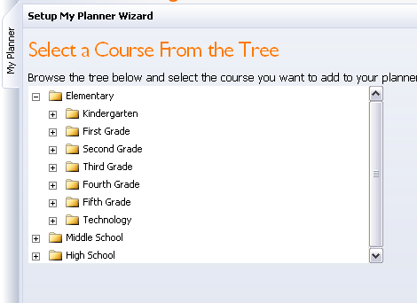Click on the + by Elementary to open the folder.

- Click on the + by the Grade level you teach.

I will use 2nd for demonstration purposes only.

- 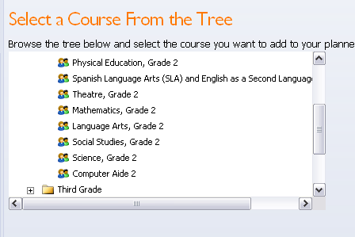When you select a grade, a list of Courses for that grade is listed.
Select the course you want. (for example: Language Arts, Grade 2). You will want to add the courses in the order that you teach them. (You can change the order later if you forget.)

When the course is selected Click NEXT.

- 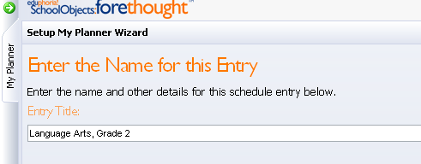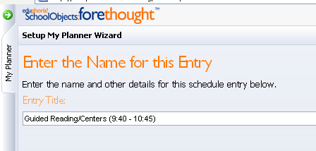On this screen it gives you the option to give it a unique name. (Language Arts TEKS are covered in Reading, Spelling, Writing, and Grammar) If you call this section of your day Reading, type that name here. If you are doing Grammar and Writing during this time, type that name here.

At this time you can add the times to your planer. After the name type the time you teach this subject.

- 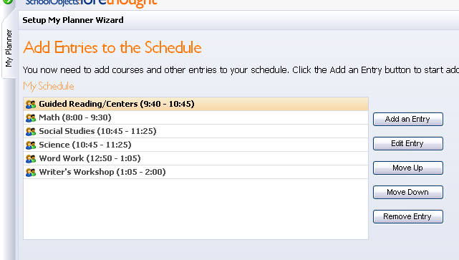Continue to add Entries to your Schedule until you have all the sections (with TEKS) you teach. For info on adding subjects without TEKS See page 5.

You may add more than one subject (i.e. LA and call it several things, such as, Word Work, Writer’s Workshop, etc.)

* Even if you don’t teach Science and Social Studies on the same day, add them both, and we will talk about that later.

A Course that Mirrors another Course in My Schedule
(Not Recommended)

Mirrored courses allow you to show the same content several times in your schedule. If something in a class needs to change for a day, you can change that day’s mirrored course and it will no longer mirror FOR THAT DAY. It may, however, be simpler to enter the course once and have special entries to indicate notes for other classes.

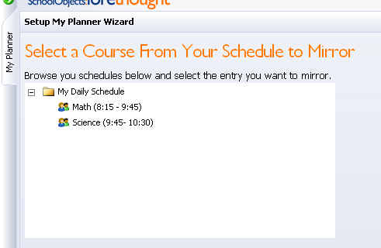*** Before you can mirror a class, you have to create the “original” class. See page 3 for information on creating this course.

You will select the course you want to mirror, and click NEXT.

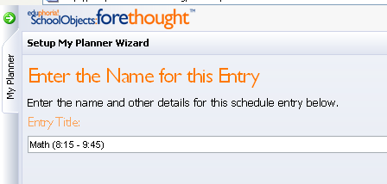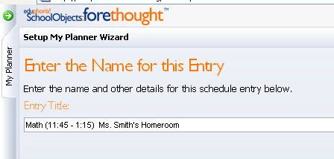On this screen it gives you the option to give it a unique name. You can keep the name and change the time, and/or put the homeroom teacher’s name.

You can repeat this process until you have mirrored all your repeat classes.

A Special Entry

A Special Entry is in a non-academic entry or can be notes about another class.
For Example: Lunch, Specials, Planning, or a section that will not have TEKS associated with it like Class Meeting or Dismissal time.

You can add a special entry at any time during your set up. I am going to add them after I have my Learning Standard classes set, to show how to rearrange your schedule later.

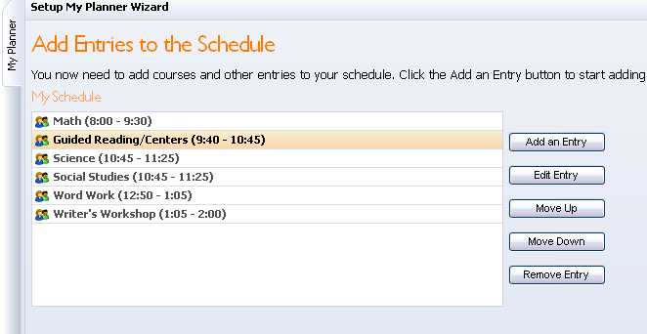Click on Add an Entry then click NEXT.
Select A Special Entry and click NEXT.
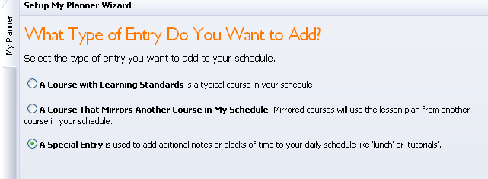

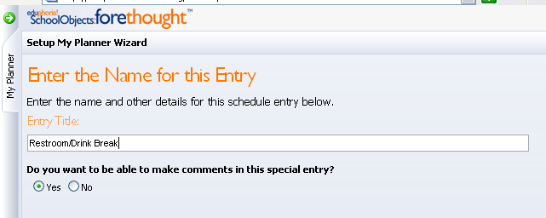Give the entry a name (i.e. restroom break, Recess, Lunch, Specials, etc.)

If you want to have the ability to write a note in this section select YES (for example, if you want to enter which specials they will go to that day).
If you do not need to leave room for notes select NO.
Click NEXT

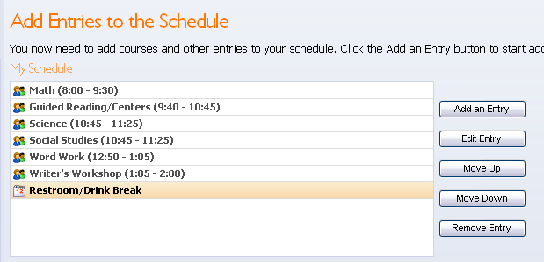The new entry will show up at the bottom. If you want to move it up (or down) in your daily schedule, click the MOVE UP (MOVE DOWN) buttons.

Continue to add Special Entries for all your non-academic sections (Specials, Lunch, Recess, Dismissal, Class Meetings, etc.).

Finishing Your Schedule

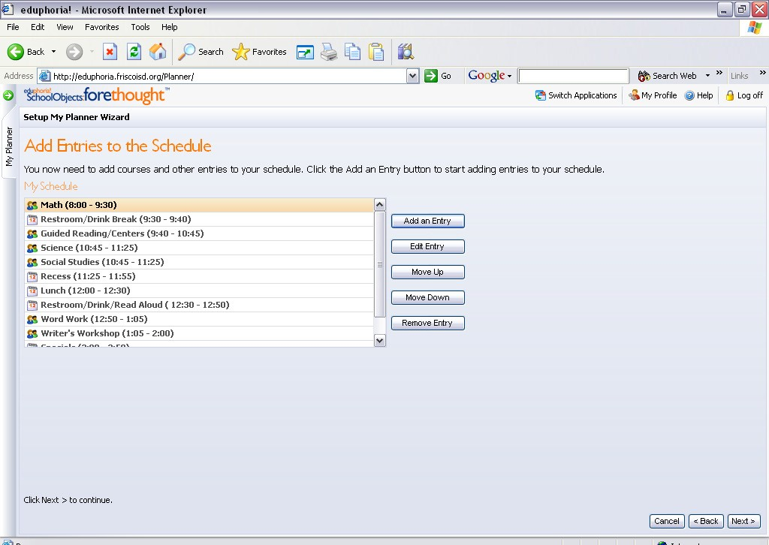

To remove an entry, highlight the selected entry and select Remove an Entry. Removing an entry from your schedule later will not erase or modify information already in your lesson planner. So, deleting Social Studies at the end of the semester WILL NOT wipe out your lesson plans for Social Studies that semester.

When you are satisfied with your Schedule you may go on to Setting up your Lesson Plan Template.
(Page 7)

Setting Up Your Lesson Plan Template

Your Lesson Plan Template is the body of your planner that will appear in each of your academic lessons.

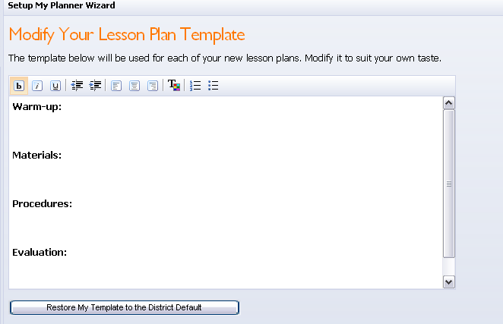You can modify your Lesson Plan Template. This template will be used in all of you academic lessons, so it may be beneficial to make it pretty general. (See Example below)

Example

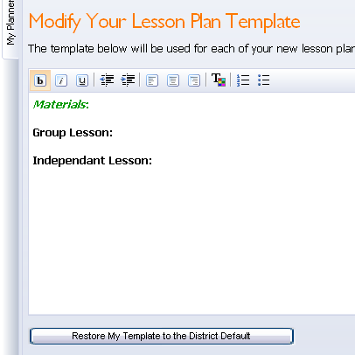If you ever want to make your template look as it did at the beginning, select Return My Template to the District Default.

When you are satisfied with your template click Begin Using forethought

CONGRATULATIONS!!!

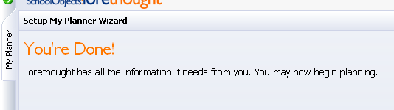

You may begin entering your lessons

